TPE – Metodologías de Desarrollo de Software I

Software Architecture Document

Version <1.0>

[Note: The following template is provided for use with the Rational Unified Process. Text enclosed in square brackets and displayed in blue italics (style=InfoBlue) is included to provide guidance to the author and should be deleted before publishing the document. A paragraph entered following this style will automatically be set to normal (style=Body Text).]

[To customize automatic fields in Microsoft Word (which display a gray background when selected), select File>Properties and replace the Title, Subject and Company fields with the appropriate information for this document. After closing the dialog, automatic fields may be updated throughout the document by selecting Edit>Select All (or Ctrl-A) and pressing F9, or simply click on the field and press F9. This must be done separately for Headers and Footers. Alt-F9 will toggle between displaying the field names and the field contents. See Word help for more information on working with fields.]

Revision History

|  |  |  |  |
| --- | --- | --- | --- |
| **Date** | **Version** | **Description** | **Author** |
| 13/06/2021 | <0.1> | Elaboración de los diagramas de secuencias, clases y actividades | Grupo 10 |
|  |  |  |  |
|  |  |  |  |
|  |  |  |  |

Table of Contents

1. Introduction 4

1.1 Purpose 4

1.2 Scope 4

1.3 Definitions, Acronyms, and Abbreviations 4

1.4 References 4

1.5 Overview 4

2. Use-Case Diagram 4

3. Structural Diagrams 5

3.1 Overview 5

3.2 Class Diagram 5

3.3 Deployment Diagram 5

4. Behavioral View 5

4.1 Overview 5

4.2 Activity Diagrams 6

4.3 Sequence Diagrams 7

Software Architecture Document

# Introduction

[The introduction of the **Software Architecture Document** provides an overview of the entire **Software Architecture Document**. It includes the purpose, scope, definitions, acronyms, abbreviations, references, and overview of the **Software Architecture Document**.]

## Purpose

This document provides a comprehensive architectural overview of the system, using a number of different architectural views to depict different aspects of the system. It is intended to capture and convey the significant architectural decisions which have been made on the system.

[This section defines the role or purpose of the **Software Architecture Document**, in the overall project documentation, and briefly describes the structure of the document. The specific audiences for the document is identified, with an indication of how they are expected to use the document.]

## Scope

[A brief description of what the Software Architecture Document applies to; what is affected or influenced by this document.]

## Definitions, Acronyms, and Abbreviations

[This subsection provides the definitions of all terms, acronyms, and abbreviations required to properly interpret the **Software Architecture Document**.  This information may be provided by reference to the project’s Glossary.]

## References

[This subsection provides a complete list of all documents referenced elsewhere in the **Software Architecture Document**. Identify each document by title, report number (if applicable), date, and publishing organization. Specify the sources from which the references can be obtained. This information may be provided by reference to an appendix or to another document.]

## Overview

[This subsection describes what the rest of the **Software Architecture Document** contains and explains how the **Software Architecture Document** is organized.]

# Use-Case Diagram

[This section lists use cases or scenarios from the use-case model if they represent some significant, central functionality of the final system, or if they have a large architectural coverage—they exercise many architectural elements or if they stress or illustrate a specific, delicate point of the architecture.]

# Structural Diagrams

## Overview

## En esta seccion se encuentran los diagramas estructurales, es decir, cómo esta formado el sistema

## C:\Users\Usuario\Desktop\Facultad\3er año 1er cuatri\Metod. de desarrollo de Software\Trabajo Practico Especial\Diagrama de clases TPE v2.pngClass Diagram

## 

## Deployment Diagram

[This section describes the configuration of run-time processing nodes and the components that live on them.]

# Behavioral View

## Overview

En esta sección se encuentran los diagramas comportamentales del Sistema.

## Activity Diagrams

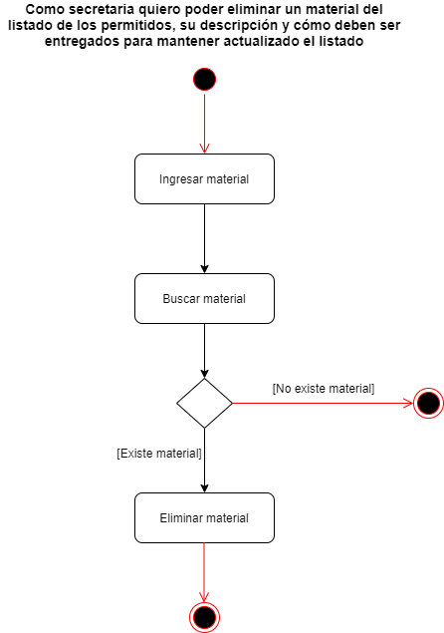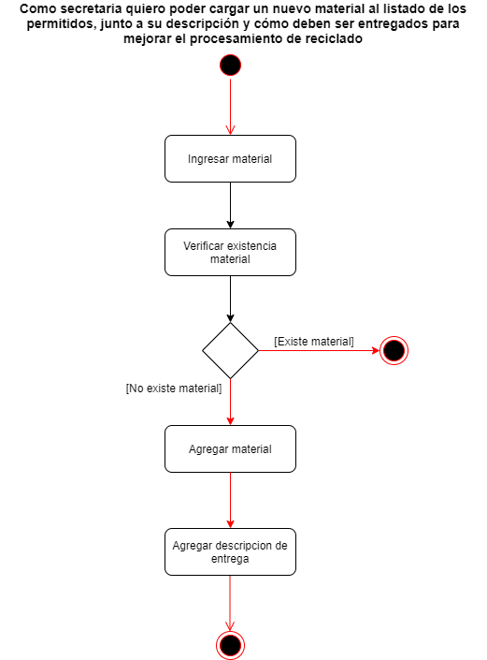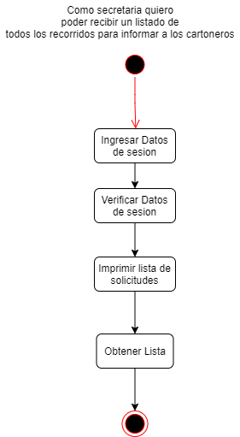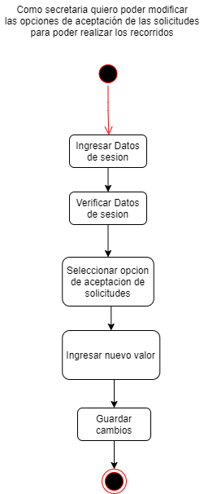A continuación se encuentran los diagramas de actividades junto a su respective caso de uso.

## https://cdn.discordapp.com/attachments/834784450734850072/854091191069704242/Diagrama_Actividades_MODIFICAR.png

## Sequence Diagram

* 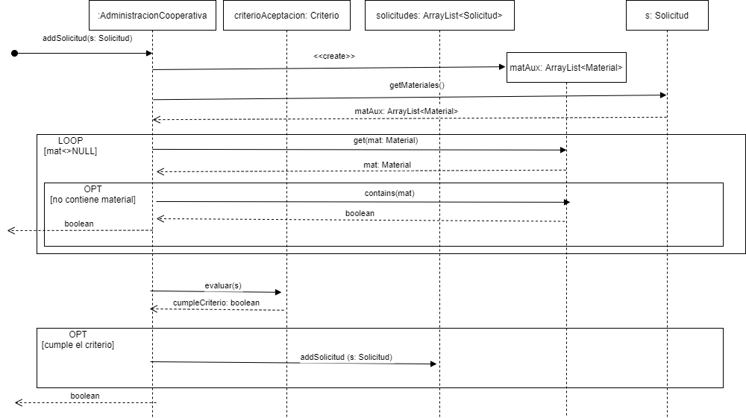Diagrama de Secuencia para agregar una nueva solicitud:
* Diagram de Secuencia para imprimir la lista de solicitudes:

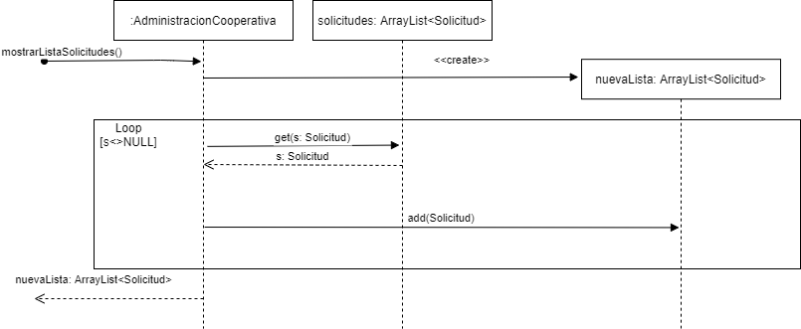

* 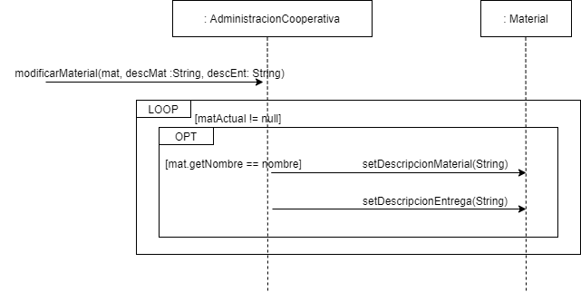Diagrama de secuencia para modificar un material de la lista:
* Diagrama de secuencia para eliminar un material de la lista:

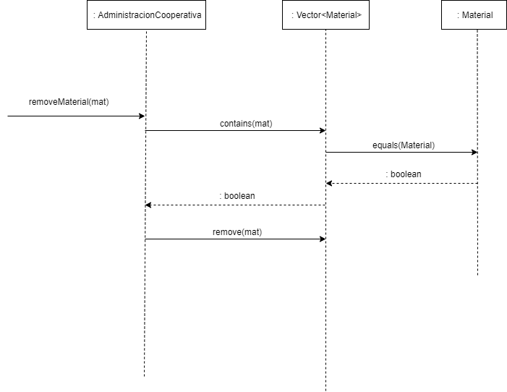

* Diagrama de secuencia para agregar un material a la lista:

